# Refresh

## The science of sleep for optimal performance and well being

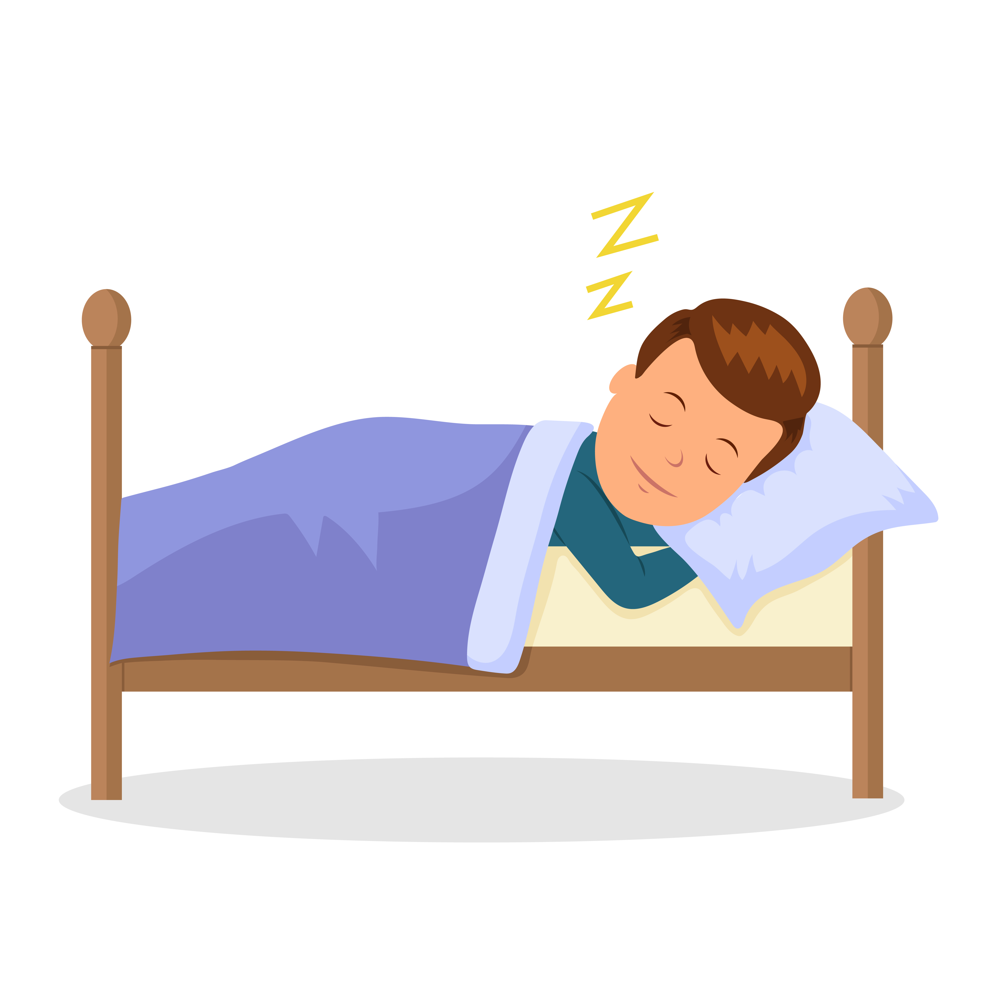

Unit 1: Introduction

For years scientists have been studying sleep and how it relates to quality of life. When your grandmother admonished you to get your “beauty sleep” she wasn’t kidding. Research has shown that good sleep doesn’t only lead to beauty, but also can have beneficial results like:

Better mood…

Improved academic performance…

Less trouble with weight management…

This program is all about helping you maximize the benefits of sleep. The strategies and skills this program teaches are part of cognitive behavioral therapy for insomnia. These skills, when taught by a trained therapist, are more effective than sleeping medications for improving sleep over time. While this program is not therapy to treat a clinical condition, with little effort, you can improve your own sleep using some of the same highly effective strategies. Give it a try and see what happens…

Like everything, good sleep takes practice. You don’t have to take cat naps every hour or go on one of those wellness retreats, you just need to spend a few minutes each day thinking about your sleep in the right way. To get the most out of the program, plan on doing both of the following:

1. Allow yourself 10 to 15 minutes every week to complete a new section of the program, for the next 8 weeks. This first unit teaches you some basic facts about sleep and introduces you to the 30 second sleep diary.

2. Between weekly units, practice the new healthy sleep habits and skills you’ll be learning.

3. Every morning when you wake up (or as early in the day as you can), fill out the 30 Second Sleep Diary. Recording your sleep habits on this form will help you track your progress.

If you are having a lot of trouble falling or staying asleep, the strategies in this program can be really helpful. However, this is not a substitute for medical care. If you are concerned about your sleep you should talk to your health care provider.

Some of the biology of sleep can be pretty interesting, even to the non- scientists. Below is a brief description of sleep stages.

There are two basic types of sleep: rapid eye movement (REM) sleep and non-rapid eye movement sleep (NREM). Sleep begins with NREM sleep, progressing through the three basic NREM sleep stages, sleep stages 1 and 2 and slow wave sleep (described below). NREM sleep is then followed by a relatively short REM sleep episode. The time between falling asleep and the end of the REM episode constitutes a sleep cycle.

NREM sleep

*Stage 1:* Stage 1 of NREM sleep is very light sleep and it occurs during transitions from awake to asleep. Your muscle tone begins to decrease during this stage but slow eye movement continues. You probably don’t even notice you’re sleeping at this stage.

Hopefully your chemistry professor doesn’t either.

*Stage 2:* During this stage of sleep, eye movements stop, and brain waves slow—with intermittent rapid wave bursts called “sleep spindles”. Most people when woken-up from stage 2 sleep realize they were sleeping. You can probably see this when you wake up your roommate, as he slowly opens his eyes, realizes that you woke him, and begins to look for something to throw at you.

*Stages 3 and 4 (slow-wave sleep):* In these stages brain waves slow further to a pattern called “delta waves” mixed with occasional spurts of faster waves. Heart rate and body temperature continue to drop, along with blood pressure and muscle tone. Eye movements remain absent. Your friend that slept through the fire drill was probably in these stages. This is the deepest most restorative stage of sleep. If your alarm clock goes off during slow- wave sleep, you may feel confused and groggy for several minutes after waking up.

REM sleep

This is when you do most of your dreaming, and is a time when your brain is actively encoding lessons learned in class recently (but you have to be awake in class to actually learn the lessons). Some people have called this type of sleep paradoxical sleep because it involves relatively fast brain activity and irregular heart rate and blood pressure, as well as characteristic rapid eye movements. During REM sleep your limbs are temporarily paralyzed, perhaps to keep your body from acting out action packed dreams. Lucky, because your roommate is really not a Rambo fan, especially when elephants are involved.

Your sleep progress through these cycles of NREM and REM sleep-architecture components about every 90 minutes. Your brain engages in most slow wave sleep earlier in the night, which will ensure you get enough of this most restorative sleep state even if you cut your night short by an early morning exam.

Scientists don’t fully understand the function(s) of sleep. They do know that you need sleep for optimal physical and mental well being. During sleep, cells manufacture more proteins, suggesting sleep is a time when the body

repairs itself. During childhood growth occurs primarily during sleep. Adequate sleep is necessary for healthy immune function, which is in part why so many students end up sick soon after a week of exams and sleep deprivation (the other part may or may not be due to the post-exam parties). Over a long term, not getting enough sleep may contribute to high blood pressure, obesity, and diabetes.

Insufficient sleep may also impact your psychological well-being, including: poor memory, poor judgment, fatigue, and increased risk of accidents. As sleep deprivation continues, feelings of sadness and exhaustion increase and bouts of irritability and anger are more frequent. So when you fail your exam after pulling four consecutive all-nighters, you’re probably going to feel even worse about it than you would normally, if that’s possible.

A small study recently published in Behavioral Sleep Medicine found that students who engage in all night study efforts actually end up with a worse GPA (Thatcher, 2008). Next time your suite mate brags about the all-nighter she pulled, feel free to chuckle and volunteer this information.

Many college students do not sleep well. A recent study found that among a random sample of students at a public university:

• Most students reported later bedtimes and wake-up times on weekends than on weekdays (shocking, we know)

• 33% took longer than 30 minutes to fall asleep

• 43% woke more than once nightly

• More than one third said they were tired during the day

(Forquer et al, 2008)

In spite of all of the above…

“DON’T LOSE SLEEP OVER NOT BEING ABLE TO SLEEP.” (Statement credited to William Dement, the father of sleep medicine)

Sleep, like adequate nutrition, is necessary for optimal health. However, obsessing over the sleep you’re not getting can actually keep you awake.

On the other hand, adopting a few healthy sleep habits will allow your brain to get into the sleep groove. This program will teach you how to make good lifestyle choices to make sleep easy.

**Practice suggestion:**

For this week, begin using the following sleep log. Print and keep it in a place where you can fill it out quickly every morning, or as early as possible after getting up for the day. You’ll be surprised how much of these details you forget as the day goes by. Save your sleep logs because you’ll need them to successfully implement this program and to track your progress over the next several weeks.

**Your Thirty Second Sleep Diary**

***Instructions for 30 second sleep diary:***As soon as possible after getting out of bed for the day, estimate and record the following times, so that you can estimate the total amount of time you spent in bed, the amount of time you were lying in bed awake, and the total amount of time you slept every night.

|  |  |  |  |  |  |  |  |
| --- | --- | --- | --- | --- | --- | --- | --- |
| **30 Second Sleep Diary** | Day 1 | Day 2 | Day 3 | Day 4 | Day 5 | Day 6 | Day 7 |
| 1. Time I got up for the day |  |  |  |  |  |  |  |
| 1. Time I went to bed |  |  |  |  |  |  |  |
| 1. **Total amount of time I spent in bed (a – b)** |  |  |  |  |  |  |  |
| 1. Amount of time it took me to fall asleep |  |  |  |  |  |  |  |
| 1. After initially falling asleep, amount of time I spent lying in bed awake |  |  |  |  |  |  |  |
| 1. **Total amount of time I spent in bed awake (d + e)** |  |  |  |  |  |  |  |
| **Total amount of time I spent sleeping (c – f)** |  |  |  |  |  |  |  |

# Refresh

## The science of sleep for optimal performance and well being

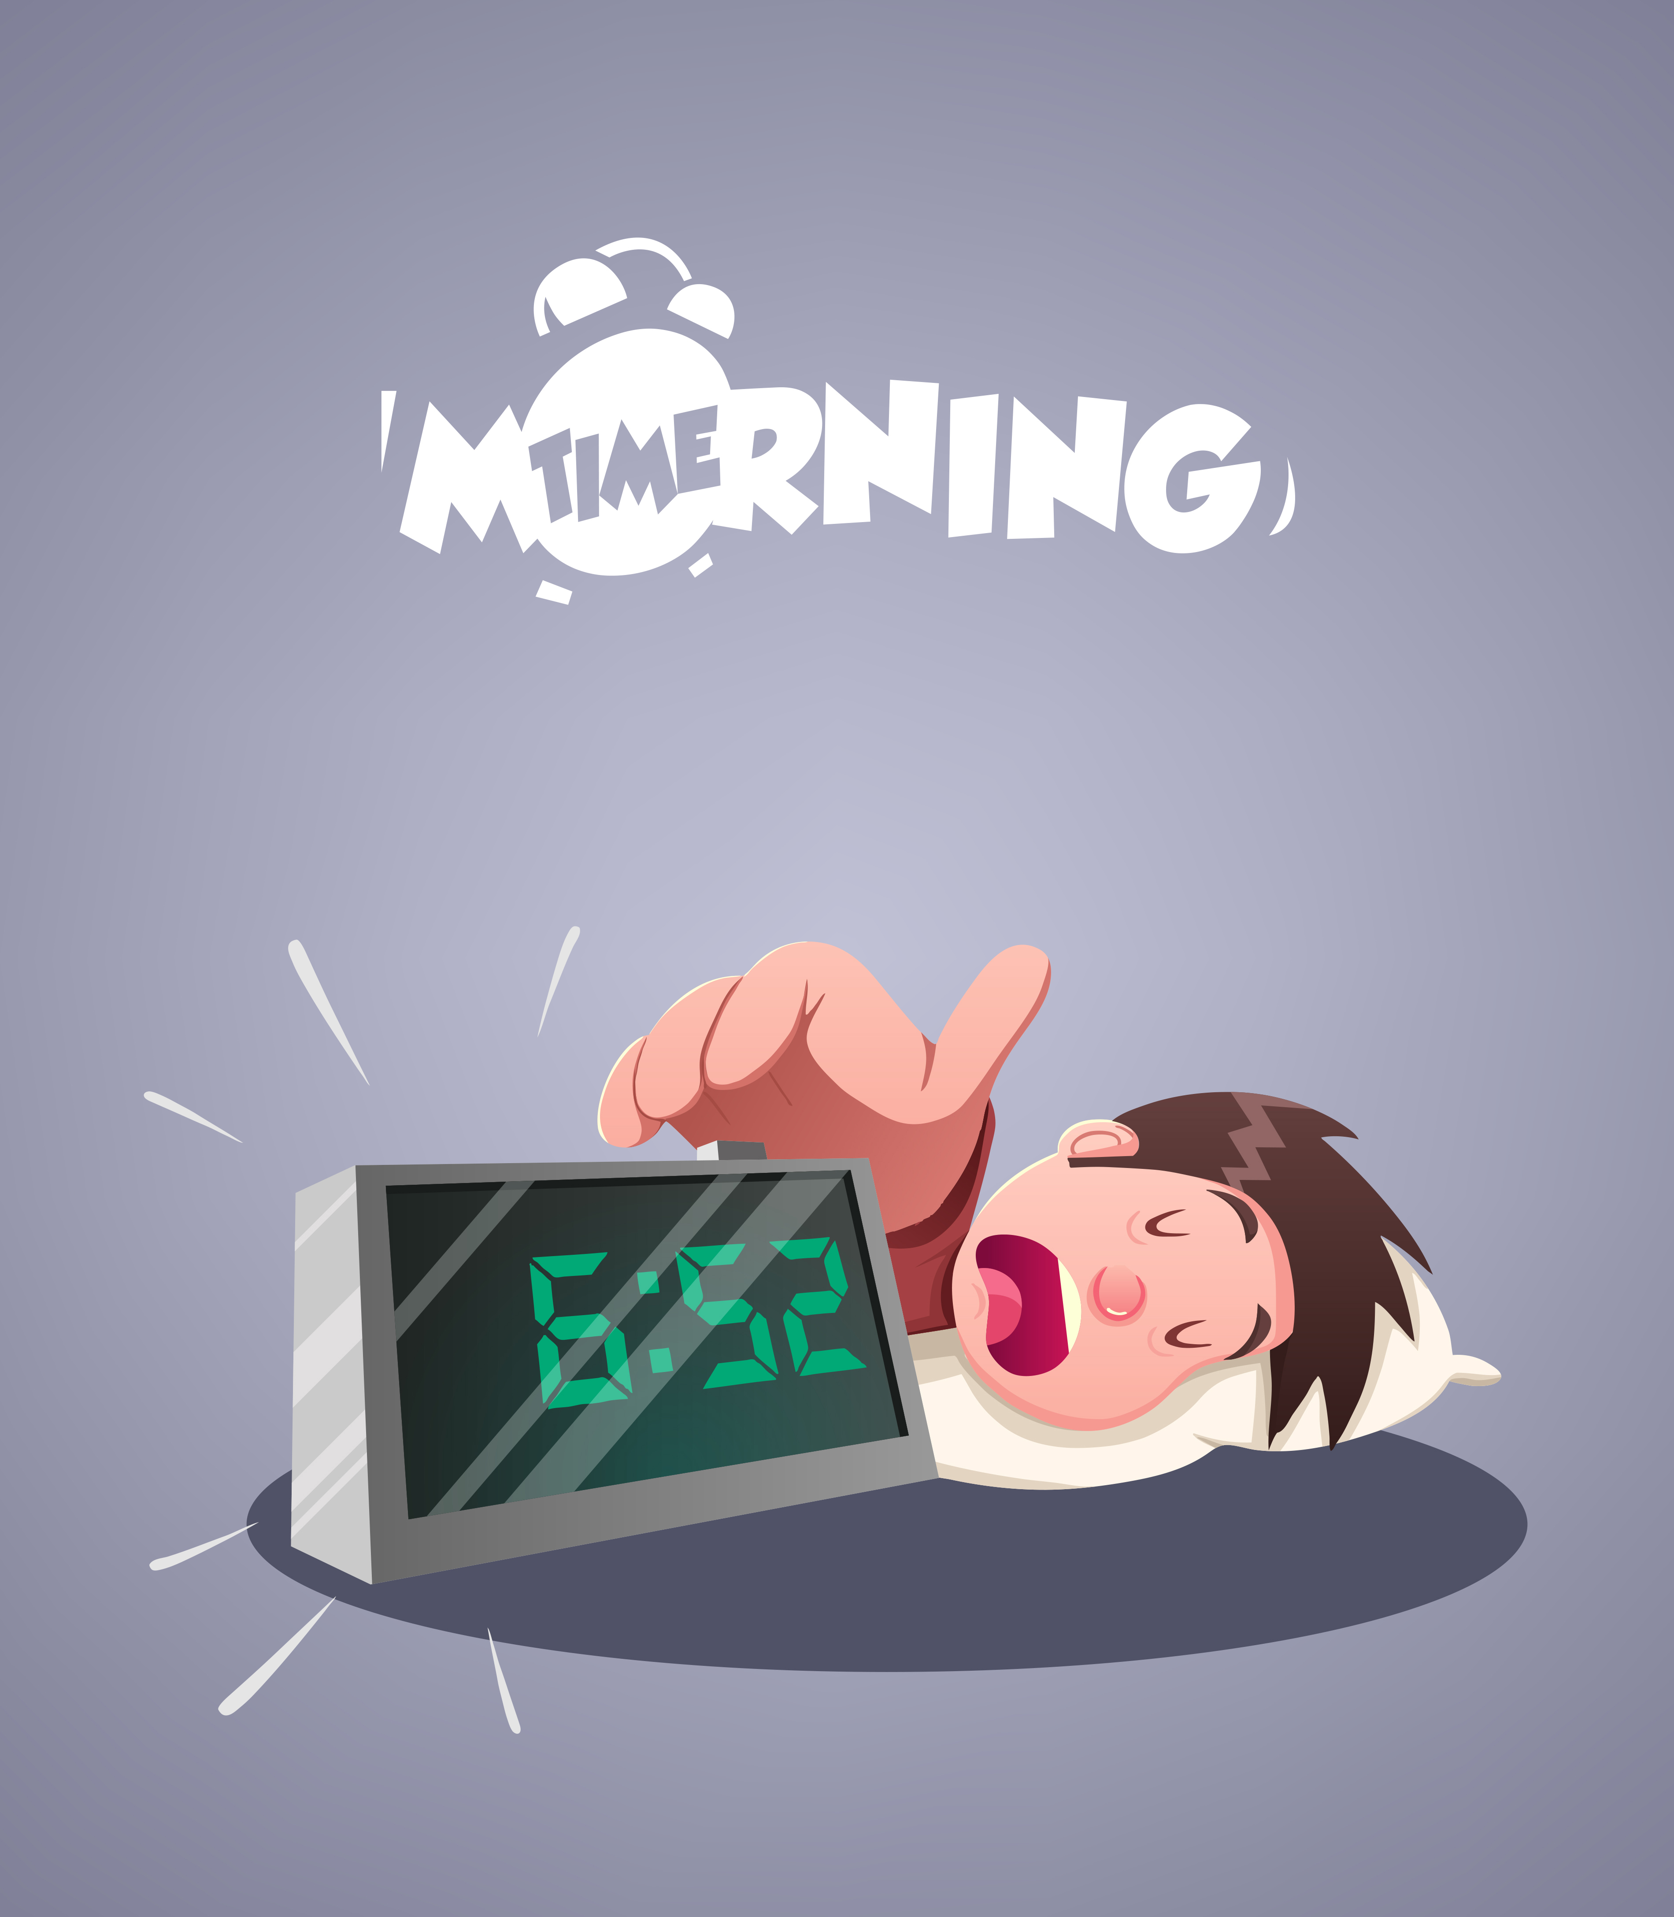

Unit 2: Tick Tock Goes the Circadian Clock: The challenge of Monday Morning Classes

Your body is constantly striving for a state of homeostasis which means it’s just trying to keep everything at a regular, normal level so you can function in the best possible way. In order to do this, it needs to tell you when to sleep. Here is a little information about how your body regulates your need for shut-eye:

During the day:

1. A biological substance called adenosine increases homeostatic drive for sleep. The longer you are awake, the higher the level of this homeostatic drive becomes.

2. Your internal circadian clock pushes back, resisting the homeostatic drive for sleep by stimulating neural pathways in the brain that promote alertness.

Note: The brain’s internal circadian clock is the suprachiasmatic nucleus of the hypothalamus. The hypothalamus is a specialized region of the brain in charge of helping maintain homeostasis by regulating variables such as temperature, blood pressure, appetite, electrolyte balance, and of course… sleep/wake cycles.

At bedtime:

1. As your usual bedtime approaches, your internal circadian clock “runs out of steam”, decreasing the strength of its alerting signals.

2. You are flooded with adenosine, and you start to feel pretty sleepy.

3. You begin your first sleep cycle.

Lots of people override their sleepiness with a little substance called caffeine, which temporarily interferes with sleep by blocking adenosine receptors in the brain.

You can also consciously override the circadian cycle to prolong wakefulness in order to stay out with friends on weekends or to stay up late studying for a test. However, the drive to sleep becomes more difficult to override as the number of sleepless hours increases.

During the night:

1. Adenosine levels decrease.

2. Alerting signals from your circadian clock are also decreased; so overall the balance remains in favor of sleep promotion and you are able to stay asleep.

In the morning:

1. Your internal circadian clock starts to increase the alerting drive.

2. Your adenosine well is dry.

3. The balance is tipped towards wakefulness and you wake-up for the day.

Fun Fact: Melatonin doesn’t just make you tan, it is also involved in the regulation of sleep and wakefulness. During the daytime, light from the sun—and other sources of bright light—suppress melatonin secretion in the brain, which increases circadian alerting signals and keeps you going through your day.

Monday is universally dreaded among students, but not only because it signals the start of a school week. It turns out that your body may be trained to hate Mondays because of your sleeping habits.

Many college students get out of sync with their weekday internal circadian clock by sleeping in late on weekends. This can cause Monday morning brain fog while you’re sitting in Music Theory, dreaming of your fluffy feather pillow. This scenario can extend to Tuesday and Wednesday morning brain fog as your circadian clock tries to re-adjust to your weekday schedule. If your weekend and weekday sleep schedules are extremely different, your performance could suffer all week. The simple mismatch between your weekend circadian clock demanding sleep and your weekday school schedule demanding attention to class can leave you miserable. This also is the reason for “jet lag” after an overseas flight. In essence, many students feel “jet lagged” every Monday, although it probably won’t get you an extension on your research paper.

Some students may easily recognize something is wrong with their sleep clock (when they wake up in a puddle of drool at the end of their history lecture). Most students will have less pronounced weekday/weekend schedule mismatch and won’t know whether it is affecting their mood or performance. More subtle symptoms of circadian clock mismatch include: decreased creativity, decreased memory, and increased irritability.

Aiming to have the same basic sleep schedule for weekdays and weekends, particularly the same rise time, can reduce symptoms of circadian clock vs. weekday schedule mismatch. You might not guess that waking up at 8:00AM on Saturdays would **decrease** your irritability, but you might be surprised.

The benefits of getting up at the same time every morning:

Authors of one study of a random sample of students living in an on-campus residence hall found that each hour earlier students reported getting out of bed on weekends predicted a 0.11 higher end of semester GPA (Trockel et al., 2000). If you are one of those people who feel best at night and would

rather not see daylight before noon, picking a strict morning wake up time is likely to be more difficult but also much more beneficial for you than for your morning-loving friends.

Of course, if you get up earlier on weekends, you’ll have to get to bed earlier in order to get enough sleep. Going to bed earlier on weekends during college may seem completely impossible, but notice we didn’t say “early” but “earlier”. If you now fall asleep at 4:00 AM on Friday nights, crashing at

1:00 AM instead might still allow you to enjoy nightlife and at the same time lead to some serious results. The same is true for waking up in the morning. If you currently get up for classes every weekday at 8:00 AM but sleep in until noon on weekends, setting a goal to get up at 10:00 AM on weekends is likely to improve your performance in and out of class. We recommend getting up at approximately the same time every day on weekdays and getting up no more than one hour later on weekends. Once you get used to living in sync with your circadian clock you will notice improvement in your sleep and your overall sense of well being.

**Make mornings something you look forward to:**

Having something you enjoy doing scheduled as your first morning activity will help you keep a constant wake time because you will be looking forward to getting out of bed. This is particularly important on weekends, when you might not otherwise have much incentive for getting out of bed until lunch time. You could exercise with a friend, plan an early morning trip to the beach, paint, read a good book in the early morning sun, watch one of those daytime TV movies that are so quality…the possibilities are endless.

Early morning sunshine:

Exposure to light first thing in the morning is a good idea, especially if you are not really a morning person. Early AM exposure to bright light can suppress sleep inducing melatonin levels and provides a cost-free alternative to fake tanning (but avoid mid-day sun exposure because skin cancer isn’t fun and you derive no circadian clock benefit form mid-day sun exposure).

If you prefer to avoid sun-exposure as much as possible, simply sitting in the shade looking out at brightly sun-lit areas is enough to reduce brain levels of melatonin and help re-set your circadian clock for earlier wake-up times.

Naps:

There’s nothing better than a short, mid-afternoon nap on a Sunday. However, napping for longer than one hour or napping late in the evening can disrupt circadian clock timing. If you like to nap, try to do it for an hour or less and get it in the afternoon before 5:00 PM.

**Practice suggestions:**

1. Determine an ideal fixed daily wake-up time. We recommend picking a weekend wake-up time that is no more than one hour later than your weekday wake-up time. However, any change to make daily wake-up times more consistent is a good move.

2. Limit naps to less than one hour and avoid naps after 5:00 PM. The best time to nap is 7 to 9 hours after your morning wake-up time.

3. Continue to use the 30 second sleep diary. Save your sleep logs so you can see how your sleep patterns change over time.

**Your Thirty Second Sleep Diary**

***Instructions for 30 second sleep diary:***As soon as possible after getting out of bed for the day, estimate and record the following times, so that you can estimate the total amount of time you spent in bed, the amount of time you were lying in bed awake, and the total amount of time you slept every night.

|  |  |  |  |  |  |  |  |
| --- | --- | --- | --- | --- | --- | --- | --- |
| **30 Second Sleep Diary** | Day 1 | Day 2 | Day 3 | Day 4 | Day 5 | Day 6 | Day 7 |
| 1. Time I got up for the day |  |  |  |  |  |  |  |
| 1. Time I went to bed |  |  |  |  |  |  |  |
| 1. **Total amount of time I spent in bed (a – b)** |  |  |  |  |  |  |  |
| 1. Amount of time it took me to fall asleep |  |  |  |  |  |  |  |
| 1. After initially falling asleep, amount of time I spent lying in bed awake |  |  |  |  |  |  |  |
| 1. **Total amount of time I spent in bed awake (d + e)** |  |  |  |  |  |  |  |
| **Total amount of time I spent sleeping (c – f)** |  |  |  |  |  |  |  |

**Refresh**

The science of sleep for optimal performance and well being

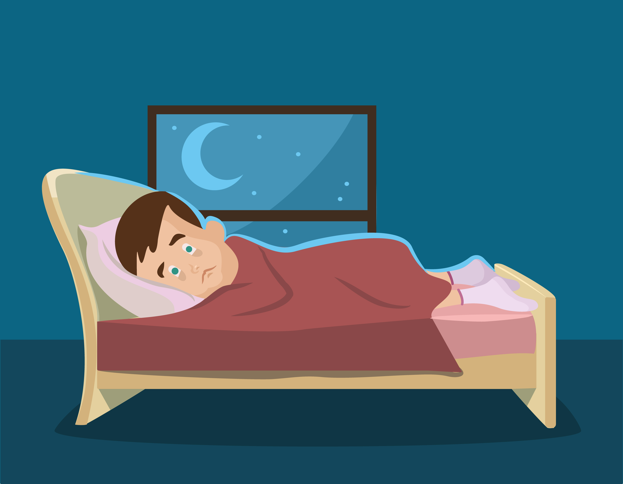

**Unit 3: Sleeping Less to Sleep More?**

Remember the bio babble from last week about sleep? The basic gist was: The longer you’re awake, the more intense sleep drive becomes and the more likely it is that you’ll want to crash. Your internal sleep clock will take care of your sleep needs under normal conditions, as long as other circumstances don’t get in the way. Other circumstances include: thinking about that girl on the second floor, thinking about your biochem test or thinking about that girl on the second floor’s biochem test (which may mean you’re a little too into her).

Unfortunately, if you are frequently having difficulty sleeping, worrying about sleeping may be one of the things keeping you awake. If this is your deal, the quickest tip for getting to sleep (without meds) is to create more of something called sleep debt, in a thoughtful controlled way. This may be the only kind of debt you actually try to create (but don’t worry, there’s no interest). In order to break the cycle of insomnia, you may need to be willing to restrict your sleep to a regular shorter block of time at first.

If you sleep less than 90% of the time you spend trying to sleep, this section may be especially important.

A word of caution:

If any of the following apply to you, do not attempt this chapter without the supervision of a health care provider:

o You have Bipolar Affective Disorder

o You have a family member with Bipolar Affective Disorder

o You have had a period of time lasting one week or longer during which

you felt euphoric, felt like you had special abilities other people don’t

have, or felt persistently irritable

o Within the last two months you started a medication to treat depression or anxiety

o You frequently have trouble staying awake while driving or performing other activities in which drowsiness may have fatal consequences

o You have a long road trip coming up within the next three weeks and you have to be the driver, or you have to or perform other activities in which drowsiness may have fatal consequences

If you can safely say that none of the above applies to you, you can begin this powerful technique for breaking the pattern or insomnia. However, if you find that you begin to have an abnormally elevated or irritable mood, feel like your thoughts are racing, or feel like you do not need more than a few hours of sleep every night, stop this procedure and contact your health care provider.

**How to break the cycle of sleep trouble: Sleep Restriction**

1. Determine the average number of hours you sleep at night:

A. Using your sleep log, add up the total number of hours you have slept during the last 7 nights. If a given night was atypical for you (for example, if you were taking a red eye flight) do not include that night in your computation.

B. Divide the total by 7 (or 6 if you deleted one night). Here’s an

example: Dave slept a total of 45 hours over the last 7 nights. Dividing by 7 yields an average nocturnal sleep time of approximately 6.4

hours.

2. Calculate the number of hours you should schedule for sleep:

A. Round your estimated average number of sleep hours up to the nearest 1/4 hour. Then add another 1/2 hour. Dave’s average, rounded up to the nearest 1/4 hour is 6.5 hours. Adding another 1/2 hour results in a calculated sleep period of 7 hours.

3. Determine your time in bed:

A. Remember that last week you thought about establishing a daily wake-up time. The closer you are able to match your scheduled sleep time with your current biologic clock, the faster your sleep will improve. The important thing is to schedule a sleep period every night to allow for the number of hours you calculated above, and to have nearly the same morning wake up time every morning (or as close as you can get).

B. Starting with your morning wake-up time, count backwards by the number of sleep hours you calculated above to determine your bedtime.

4. Making your new sleep schedule work for you:

A. You should go to bed when you feel sleepy or at your scheduled bedtime, whichever comes **later**.

B. Your rise time should be fixed. Even if you had difficulty sleeping at night, set an alarm and get out of bed shortly after it rings.

C. Do not spend fewer than six hours in bed per night. If on any given night you are waiting to go to bed until you feel tired and have only six hours before your scheduled wake-up time, go to bed anyway; don’t try to sleep, just relax and allow your brain to sleep if it wants to. If you consistently follow your schedule, waking up at the same time every morning, you will most likely begin feeling sleepy closer and closer to your bedtime.

D. If you do not feel sleepy at your bedtime, make sure you allow

yourself at least one hour before bedtime to relax and unwind from the day’s stresses. Avoid studying (yay!), playing crazy video games or doing anything that’s going to get your heart rate up.

Let’s get back to our friend Dave. Dave decided that he should schedule a time period in bed of 7.0 hours. He also found that, on average, he falls asleep between 11:00 PM and midnight. His earliest class is a Monday, Wednesday, and Friday chemistry class at 8:00 AM. If he wakes up at 7:00 AM, he has enough time to get ready for the day and make it to his 8:00 class. To motivate himself to stick with a 7:00 AM rise time, he decided that on days he doesn’t have early morning classes he will go to the gym with Andrea. (It doesn’t hurt that Andrea looks like Angelina Jolie!)

Following a sleep schedule will help you train yourself to go to sleep at a regular time, rather than with worrying about getting to sleep and feeling anxious about not sleeping. As long as you are allowing yourself a consistent opportunity to sleep every night and you’re getting out of bed every morning at the same time, you probably don’t need to worry about how much sleep you get during any given night. The less you sleep tonight, the more sleep debt you will have tomorrow night, and the more you will sleep then. As you allow yourself a regularly scheduled opportunity to sleep, in time, your brain will take care of sleep for you.

The first few days may be rough, particularly if you are trying to change the time you usually wake up. Soon your body will adjust. Consider it a self- imposed "Daylight Savings Time".

If you find yourself having trouble sleeping consistently during the first few days of your new schedule, it may actually be a good thing. This will increase your sleep debt and help you adjust to your schedule faster. You’ll soon notice that you’re falling asleep more quickly in bed and will begin to feel more refreshed in the morning. Say goodbye to sleepless hours in bed listening to your roommate snore; this new strategy teaches your mind that the bed is for sleeping, not for worrying, counting sheep, or praying for a new roommate.

Even though you are spending less time in bed, you might feel more refreshed in the morning because your sleep will be more consolidated.

You’ll be able to sleep for a greater proportion of the time you’re spending in bed. In spite of an improvement in sleep quality, you may still feel tired during the day. If after two weeks you are still tired, you should add ½ hour to your scheduled block of time in bed. You will continue to add small bits of time every week, if needed, until your sleep time is optimal for you. First you will shorten your sleep to improve sleep quality, then you will be able to gradually increase sleep time as needed.

**Practice suggestions:**

1. Follow the above procedure and begin establishing a consistent specific sleep schedule using these recommendations. Follow your new sleep schedule during the next 14 days.

2. Continue to use the 30 second sleep diary. Don’t forget to save your sleep logs. You’ll continue to use them to make small adjustments to your sleep schedule.

**Your Thirty Second Sleep Diary**

***Instructions for 30 second sleep diary:***As soon as possible after getting out of bed for the day, estimate and record the following times, so that you can estimate the total amount of time you spent in bed, the amount of time you were lying in bed awake, and the total amount of time you slept every night.

|  |  |  |  |  |  |  |  |
| --- | --- | --- | --- | --- | --- | --- | --- |
| **30 Second Sleep Diary** | Day 1 | Day 2 | Day 3 | Day 4 | Day 5 | Day 6 | Day 7 |
| 1. Time I got up for the day |  |  |  |  |  |  |  |
| 1. Time I went to bed |  |  |  |  |  |  |  |
| 1. **Total amount of time I spent in bed (a – b)** |  |  |  |  |  |  |  |
| 1. Amount of time it took me to fall asleep |  |  |  |  |  |  |  |
| 1. After initially falling asleep, amount of time I spent lying in bed awake |  |  |  |  |  |  |  |
| 1. **Total amount of time I spent in bed awake (d + e)** |  |  |  |  |  |  |  |
| **Total amount of time I spent sleeping (c – f)** |  |  |  |  |  |  |  |

**Refresh**

The science of sleep for optimal performance and well being

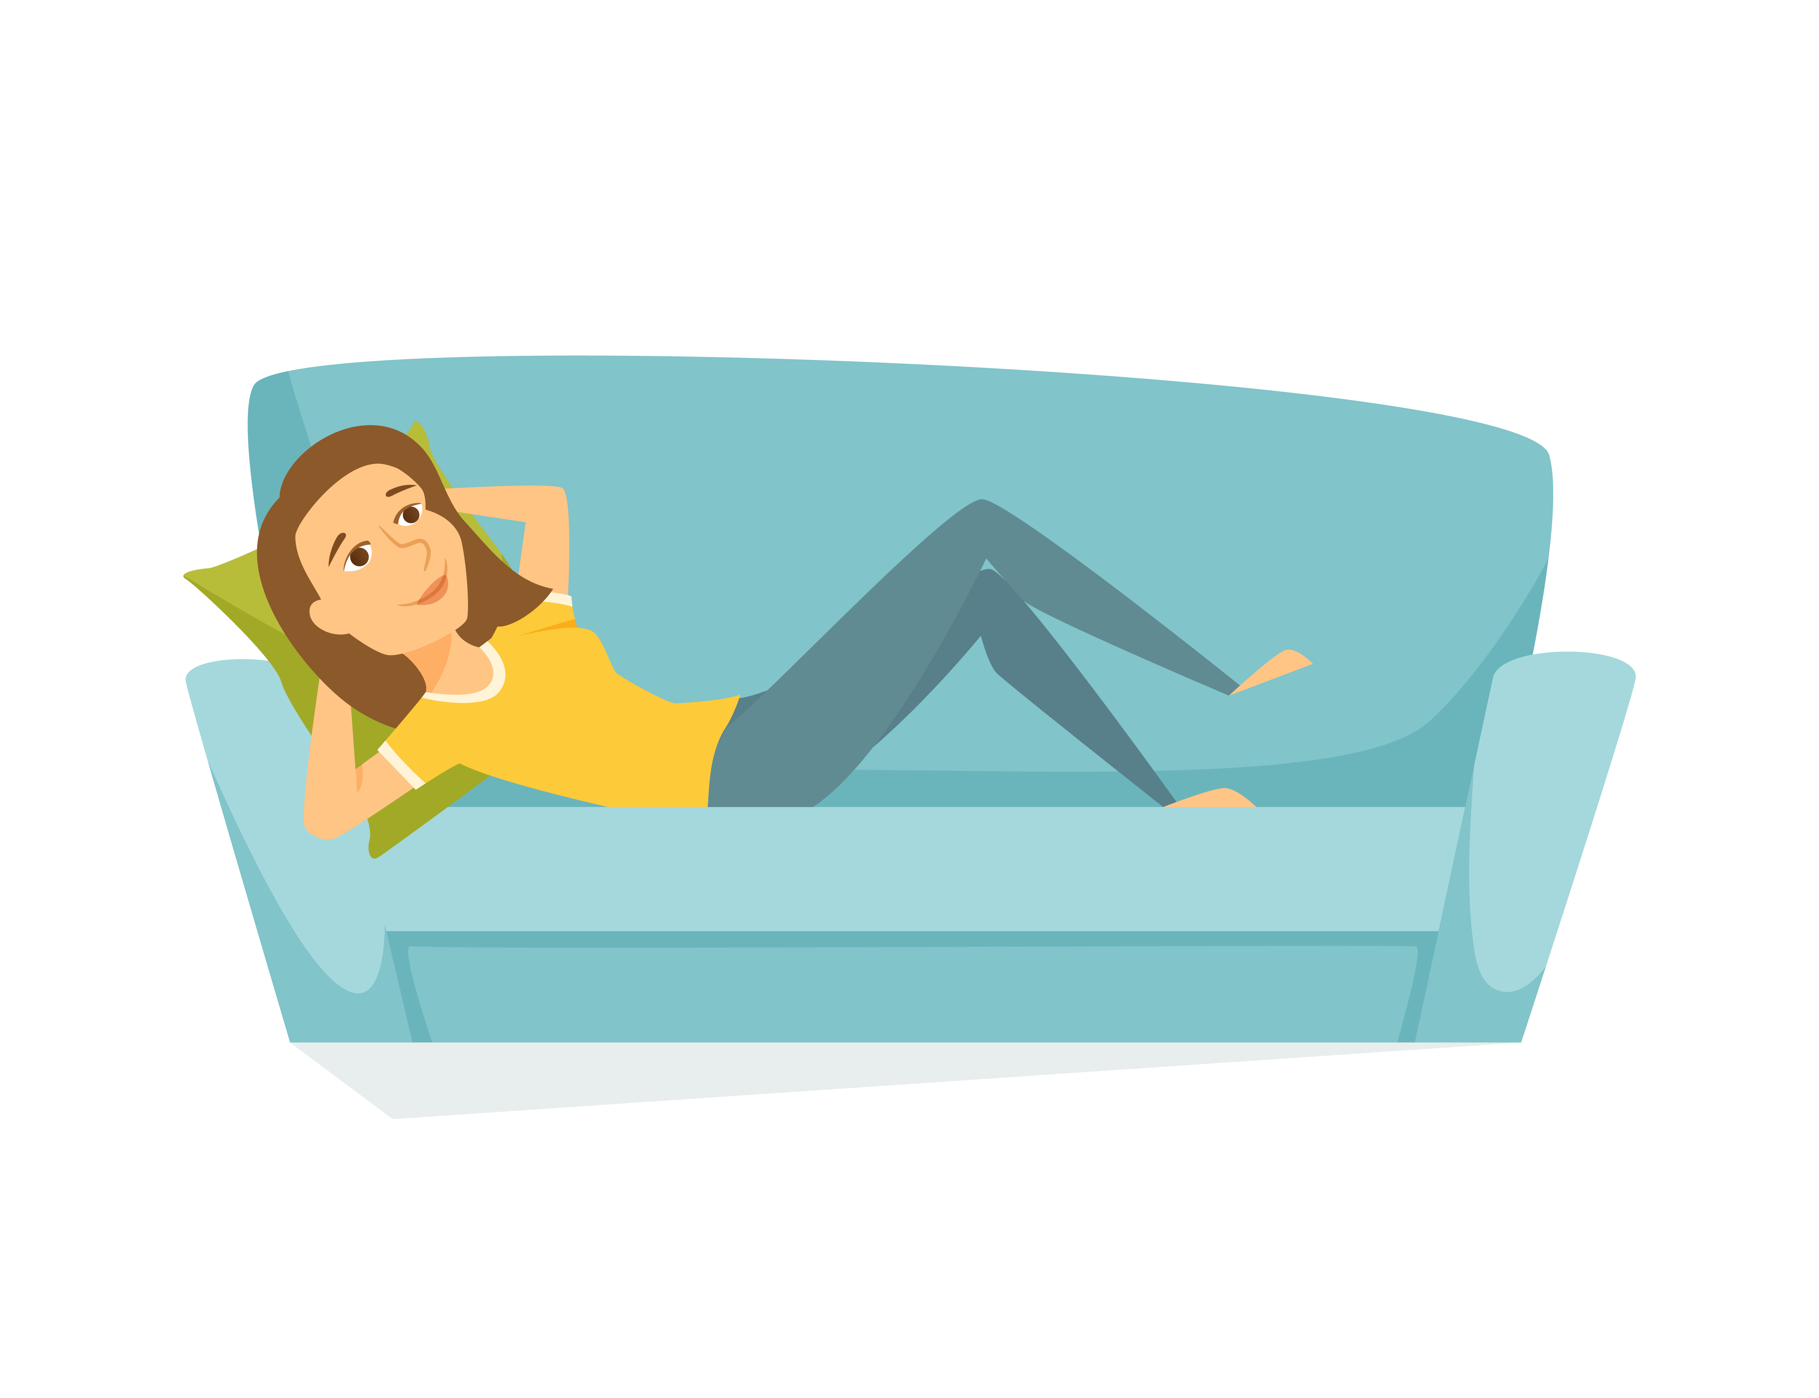

**Unit 4: Chill-out Before Bedtime**

Taking some time to unwind before bedtime can definitely help improve the quality of your sleep. Things to avoid during this time include anything that amps you up, even hardcore studying. Avoid the gym, the *Saw* sequel, the dorm-wide Frisbee golf tournament, and the lovers’ quarrel if you’re planning to sleep in the next hour.

Instead, try chilling with friends (but avoid discussing politics, sports, or anything else that gets your mind going faster), reading a good book, listening to music (maybe save the techno for another time), writing in your journal, or even trying some of the relaxation exercises described below.

Relaxation exercises:

*Deep Breathing:*

Sit, or lay down in a comfortable position.

1. Place one hand over your abdomen and one hand over your chest.

2. As you breathe, pay attention to which hand moves more.

3. Take a slow deep breath focusing, as you inhale, on breathing with your abdomen so that the hand on your abdomen moves first. As you continue to inhale, allow your chest to expand as well.

4. Gently exhale slowly and completely.

Take a few more deep breaths, noticing the deep feeling of relaxation. You may notice the greatest sense of relaxation during exhalation.

5. Placing one hand on your abdomen and the other on your chest is to help you learn to expand your abdomen as you breathe deeply. After learning this, you can place your hands in any position most comfortable for you, such as in your lap or at your sides.

*Meditative breathing, adding a focus:*

1. Begin deep breathing.

2. With each inhalation, repeat a soothing word in your mind (e.g., “peace”).

3. With each exhalation, repeat a soothing word in your mind (e.g., “love”).

4. At the end of each exhalation, count (in your mind) the number of deep meditative breaths you’ve completed.

5. Continue until you reach 20.

Whenever you notice your mind has wandered, gently bring your attention back to your breathing and the soothing words. The more often your mind wanders, the more opportunities you have to practice gently bringing your attention back to your breathing and the soothing words. If you are practicing shortly before bedtime, you might actually fall asleep before you get to 20 deep breaths. If that happens, crawl into bed and allow yourself to fall asleep.

To learn another, somewhat more involved relaxation technique, continue reading:

*Progressive muscle relaxation:*

Sit or lay in a comfortable position.

Take a few deep breaths, noting the feeling of relaxation.

Gently tighten the muscles in your lower legs, allowing the tension to build for a few seconds.

Hold the tension in your lower legs for a few more seconds; then release it, allowing all of the tension to flow away from your lower legs and out with a gentle slow exhalation.

Notice the feeling of deep relaxation in your lower legs.

Gently tighten the muscles in your thighs and buttocks, allowing the tension to build for a few seconds.

Hold the tension for a few more seconds; then release it, allowing all of the tension to flow from your thighs and buttocks and out with a gentle slow exhalation.

Notice the feeling of deep relaxation throughout your legs and buttocks.

Gently tighten the muscles in your abdomen, allowing the tension to build for a few seconds.

Hold the tension for a few more seconds; then release it, allowing all of the tension to flow from your abdomen and out with a gentle slow exhalation.

Notice the feeling of deep relaxation in your abdomen.

Gently close your fists and tighten the muscles in your arms and chest, allowing the tension to build for a few seconds.

Hold the tension for a few more seconds; then release it, allowing all of the tension to flow from your arms and chest and out with a gentle slow exhalation.

Notice the feeling of deep relaxation in your chest and arms.

Notice the feeling of relaxation spreading throughout your body.

Gently tighten the muscles in your face. Close your eye lids, press your lips together, and wrinkle your forehead, allowing the tension to build for a few seconds.

Hold the tension in your face and forehead for a few more seconds; then release it, allowing all of the tension to flow out with a gentle slow exhalation.

Notice the feeling of deep relaxation in your face and forehead.

Notice the deepening feeling of relaxation throughout your body as you take a few more gentle deep breaths, allowing any remaining tension anywhere in your body to flow out with each exhalation.

*Notes on variation of this technique:*

You can change the order of the above, or divide body areas into smaller muscle groups. For example you can focus on the right and left arms separately, or the thigh muscles and

buttocks separately. You can experiment and discover what works best for you to release

tension and relax.

**Practice Suggestions:**

1. Continue following the sleep scheduling you began last week.

2. Practice setting aside some time to unwind before bedtime, doing things that are both enjoyable and relaxing for you.

3. Practice a relaxation exercise for 5 to 10 minutes shortly before going to bed, or right after crawling into bed.

4. Continue to use the 30 second sleep diary.

**Your Thirty Second Sleep Diary**

***Instructions for 30 second sleep diary:***As soon as possible after getting out of bed for the day, estimate and record the following times, so that you can estimate the total amount of time you spent in bed, the amount of time you were lying in bed awake, and the total amount of time you slept every night.

|  |  |  |  |  |  |  |  |
| --- | --- | --- | --- | --- | --- | --- | --- |
| **30 Second Sleep Diary** | Day 1 | Day 2 | Day 3 | Day 4 | Day 5 | Day 6 | Day 7 |
| 1. Time I got up for the day |  |  |  |  |  |  |  |
| 1. Time I went to bed |  |  |  |  |  |  |  |
| 1. **Total amount of time I spent in bed (a – b)** |  |  |  |  |  |  |  |
| 1. Amount of time it took me to fall asleep |  |  |  |  |  |  |  |
| 1. After initially falling asleep, amount of time I spent lying in bed awake |  |  |  |  |  |  |  |
| 1. **Total amount of time I spent in bed awake (d + e)** |  |  |  |  |  |  |  |
| **Total amount of time I spent sleeping (c – f)** |  |  |  |  |  |  |  |

**Refresh**

The science of sleep for optimal performance and well being



**Unit 5: The Magic of Mindfulness**

We realize that everyone has different ideas about how to relax. Some people are more open to alternative techniques for relaxation, others prefer to zone out with a Lifetime movie. While we realize you might be skeptical, we want to introduce you to a technique that’s catching on with CEOs, pop stars, health professionals and even (gasp!) college students. Mindfulness is the practice of living in the moment. It may sound pretty easy, but it actually can be difficult, especially for achievement-minded college students.

A growing body of research suggests mindfulness practice may help improve sleep as well as physical and emotional well-being.

Mindfulness can be practiced in lots of different ways. To start, try incorporating it into the deep breathing exercises we discussed last week.

*Mindfulness focused breathing:*

*“The mind is like a monkey, it goes in a thousand different directions, but the breath only goes in two”*

1. Begin deep breathing, like you learned last week.

2. Focus your attention to the experience of breathing. For example:

-Notice how your how the air feels as it rushes through your nostrils and down into your lungs.

-Notice how the air feels as it gently flows out from your nostrils.

-Notice the sound of the air flowing in with inhalation and out with exhalation.

-Notice the feeling of your clothing on your abdomen, chest, and shoulders as your abdomen and chest expand and relax with each breath.

Sounds silly, until you try it and walk away relaxed for the first time all week. There is no way to fail in mindfulness practice. However, it’s important that you’re able to suspend judgment. When you notice your mind has wandered, gently bring your attention back to your breathing. Likewise, if you notice your thoughts are judgmental, gently bring your attention back to your breathing.

Read below for another common mindfulness exercise.

*Body-scan mindfulness exercise:*

Start with mindfulness deep breathing described above. Then scan over each body part as follows (or in another order and combination you prefer):

1. Bring your attention to your feet, notice all sensations in your feet. Are your feet warm or cold? Is there any pain or discomfort? Are there any points of pressure? Can you feel the

socks on your feet, or cool sheets on your bare feet? Without any judgment, simply allow yourself to focus on these sensations. If you find yourself judging a feeling of pain, pressure, or a subtle sensation as either good or bad, gently bring your attention back to the sensations themselves. Whenever you find your mind wandering, gently bring your attention back to the sensations of your feet. The more your mind wanders, the more opportunities you have to practice.

2. Repeat the process, bringing your attention to your legs. Are your legs warm or cold? Is there any pain? Are there any points of pressure? Can you feel the clothes or blankets touching your skin? Without any judgment, simply allow yourself to focus on these sensations. If you find yourself judging a feeling of pain, pressure, or a subtle sensation as either good or bad, gently bring your attention back to the sensations themselves. Whenever you find your mind wandering, gently bring your attention back to the sensations of your legs. The more your mind wanders, the more opportunities you have to practice.

3. Repeat the same process, bringing your attention to your abdomen…

4. Then, bringing your attention to your chest…

5. Then, bringing your attention to your back…

6. Then, bringing your attention to your shoulders…

7. …arms…

8. …hands…

9. …neck…

10. …face…

11. …ears…

12. …scalp…

How’s it been going? Follow-up on the success of your sleep scheduling efforts:

1. Use your sleep log to calculate the total number of hours you have slept over the last week.

2. Divide by 7 to determine the average number of hours you sleep every night.

3. Determine the average time it takes every evening to fall asleep.

4. Determine the total average amount of time you spend in bed awake.

Here is how to make adjustments to your recommended sleep schedule, if needed:

Determine if both of the following have been true for you over the last week.

1. Are you able to fall asleep, on average, within 30 minutes at night?

2. Do you spend, on average, less than 45 minutes lying in bed awake during the night?

If you answer yes to both questions above, consider how refreshed you feel during the daytime. Are you tired during most daytime hours? If not, you should probably continue with your current sleep schedule. On the other- hand, if you are sleeping well during the time you schedule for sleep but remain tired during much of the day, try adding 1/2 hour to your sleep schedule, consistently getting up 1/2 hour later or going to bed 1/2 hour earlier.

If you answer "no" to one or both of the questions listed above, consider making some adjustments. Are you waking up at the same time every morning? Are you avoiding alcohol late in the evening and coffee after lunch time? If you haven’t done so already, try eliminating all caffeine after lunch time and all alcohol entirely. If this seems completely unrealistic, try cutting back. We realize everyone has different habits, but any change in the right direction is a good one. Be sure to avoid daytime naps longer than one hour and to avoid taking naps late in the evening. If you are already doing all of these things and are still consistently unable to fall asleep in less than 30 minutes after going to bed, or if you are spending a total of 45 minutes or more during the night lying in bed awake, consider reducing the number of hours you are scheduling for sleep by 1/2 hour.

**DO NOT** restrict nighttime sleep to less than 6 hours per night. Even if you are not able to sleep for six hours in a row, allow yourself to relax in bed during six consecutive hours per night, so your body can sleep as much as it wants to during that period of time.

**Practice Suggestions:**

1. Make adjustments to your sleep schedule following the steps outlined above and implement your new sleep schedule during the next 14 days.

2. Practice mindfulness breathing or another mindfulness exercise for at least 10 minutes daily.

3. Continue to use the 30 second sleep diary. Keep saving your sleep diaries. You’ll continue to use them to make adjustments to your sleep schedule.

**Your Thirty Second Sleep Diary**

***Instructions for 30 second sleep diary:***As soon as possible after getting out of bed for the day, estimate and record the following times, so that you can estimate the total amount of time you spent in bed, the amount of time you were lying in bed awake, and the total amount of time you slept every night.

|  |  |  |  |  |  |  |  |
| --- | --- | --- | --- | --- | --- | --- | --- |
| **30 Second Sleep Diary** | Day 1 | Day 2 | Day 3 | Day 4 | Day 5 | Day 6 | Day 7 |
| 1. Time I got up for the day |  |  |  |  |  |  |  |
| 1. Time I went to bed |  |  |  |  |  |  |  |
| 1. **Total amount of time I spent in bed (a – b)** |  |  |  |  |  |  |  |
| 1. Amount of time it took me to fall asleep |  |  |  |  |  |  |  |
| 1. After initially falling asleep, amount of time I spent lying in bed awake |  |  |  |  |  |  |  |
| 1. **Total amount of time I spent in bed awake (d + e)** |  |  |  |  |  |  |  |
| **Total amount of time I spent sleeping (c – f)** |  |  |  |  |  |  |  |

**Refresh**

The science of sleep for optimal performance and well being

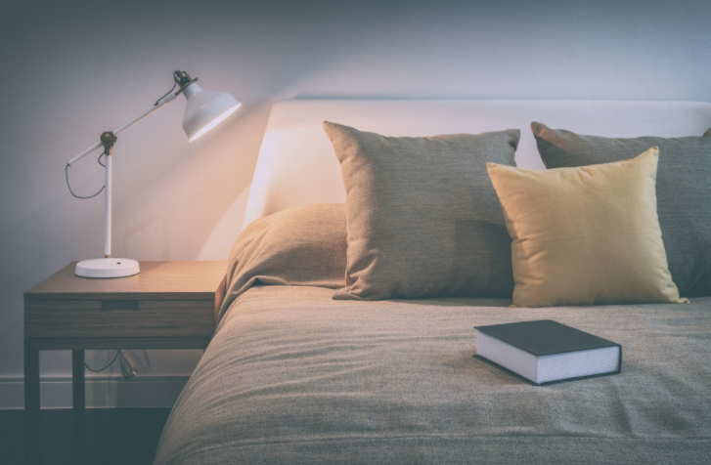

**Unit 6: Keeping it Quiet: Constructing Your Sleep**

**Environment**

Anyone up for a night cap?

1. After the party: the effects of alcohol on sleep…

It turns out that late drink probably does more damage than good to sleep quality. While alcohol might help you crash, it is also likely to cause fitful sleeping in the middle of the night and can decrease deeply restorative slow wave sleep (see Introduction, section on slow-wave sleep). Many people report waking up super-early after a night of drinking, which can wreak havoc on your circadian clock, not to mention your memory, mood and behavior. For optimal sleep, cut back on the alcohol before bed time.

This is my third latte…

2. Caffeine can keep fuel that daytime hurry… and the nighttime worry

It can take between 9 and 21 hours for your liver to metabolize most of the caffeine in your system. You may still be feeling that morning espresso at the end of *The Hills*. If you drink caffeinated beverages, we recommend that you avoid them after lunch time, to give your liver a fighting chance at eliminating enough of the drug to allow your brain to sleep at bedtime.

Note: For ladies on birth control, the effects of caffeine may stick around even longer. This is because birth control pills can reduce the speed at which your liver is able to eliminate some drugs, including caffeine.

Midnight flag-football in the Quad!...

3. Aerobic exercise and sleep…

We love exercise, in fact some studies suggest that working out may even help improve your sleep. Just not working out right before bedtime. Before you sleep, your body needs to decrease your internal temperature. If you are exercising right before bedtime, you may be interfering with this process. Your body temperature drops slightly a few hours after exercise; so the best time to exercise is probably about 3 to 6 hours before bedtime. This allows plenty of time to chill, both literally and figuratively.

Dude, try this new sushi roll…

4. Indigestion…not helpful for good sleep…

Ever stayed up with some serious indigestion? Even without considering how terrible running to a bathroom down the hall and exposing your roommate to some unpleasant odors can be, it can also completely interrupt your sleep.

Eating too close to bedtime can increase the risk of indigestion. However, skipping dinner can also be a problem, since feeling too hungry may increase alertness.

Making your sleep environment conducive to sleep

You need to make your mind associate your bed with sleeping. Just like that Pavlov guy taught his dogs that bell ringing = eating, you need to teach yourself that bed = sleeping. Check out the suggestions below:

1. *The Bed-Desk-Kitchen-Lounge*

Beds are for sleeping. Beds in college are also for studying, eating, stretching, reading, chatting, jumping and pretty much everything else.

They take up 75% of your half of the room; why wouldn’t you spend most of your time on them? We get that you love your Ikea zebra bedroom set, but spending a lot of time reclining can actually hurt your sleep. When people are having trouble sleeping, it can be because being in bed just doesn’t signal sleep to them anymore. Insomniacs who spend time reading or writing in bed start to associate their sleeping place with their books, and have trouble getting to relax when they actually need to sleep. If you find yourself having trouble sleeping, try limiting laptop use to your desk or outside your room. Keep the iPods out of the sheets and watch TV from your chair rather than your pillow. Study in the lounge or hang out on your friend’s couch. Beds are comfy, but who wants their attempts to sleep to be interrupted by flashes of your chemistry book? You’ve trained the brain to associate beds with sleep your whole life; don’t spend four years teaching it bad habits. If you’re having trouble sleeping, get rid of the distractions and reserve your bed for dreaming and not much else.

2. Do you close your eyes and see the red numbers of your clock burning into your brain, chastising you for still being awake? Well that’s scary, but one way to prevent it is to turn your clock around. Pret-ty simple. Seeing the clock when you wake up briefly in the middle of the night can lead to worry about what time it is, which can keep you up.

3. If you have trouble sleeping well, don’t go to bed at night until you’re tired. This suggestion only works well if: 1) you’re getting out of bed in the morning at a consistent time, and 2) you are giving yourself a chance to unwind before bedtime. In other words, if you are playing tennis until midnight, it’s not necessary to keep playing until 1:00 AM because you don’t feel sleep coming on yet. On the other hand, if you are reading quietly as your bedtime approaches and you’re not feeling tired yet, it’s OK to keep reading and go to bed a little later…as long as you’ll be up at the normal time the next morning.

4. If noise in your dorm environment interferes with your sleep, try using a “white noise maker”. Who wouldn’t like to sleep in the Brazilian rainforest or on a Maui beach? Actual “white noise makers” can be purchased at some drug stores and are easily found on Amazon.com. Alternatively, a fan can serve the same purpose—producing white noise that can help you sleep through roommates snoring or neighbors talking.

Read below for more ideas on how to deal with noise and improve sleep in your college environment:

Sleep and college are often at odds with each other, whether you’re pulling an all-nighter to study for your chem exam, partying until the break of dawn to celebrate a full moon or having one of those intense philosophical conversations with the dreadlocked guy across the hall. Still, without sleep, you’re not going to get very far, so it’s important to identify both what’s keeping you from sleeping and how to sneak in the shut-eye when no one is watching. Below we’ve identified some common problems college students have when they actually want to sleep, however rare it may be.

The Raucous Roommate

You like to party as much as the next girl, but a techno dance party at 5:00 AM? Sure, your roommate is from Paris or Pittsburgh or wherever they have parents with no curfew and neighbors with no ears, but seriously, Gorillaz music has a time and place and it isn’t sunup in your dorm room. It’s pretty difficult to confront other people, especially those that have access to everything you own, but if you’re going to make it work, it’s time to have a sit-down chat. Make it as pleasant as possible without sounding accusatory or sarcastic. “So Jenny, funniest thing this morning, I had this crazy dream where you were PLAYING MUSIC IN THE MIDDLE OF THE NIGHT.” Gets the point across, but at what cost? Instead take the blame yourself, but be firm. Explain that you have “different” sleeping patterns, that require at least seven-eight hours of uninterrupted sleep, with music and talking counting as interruptions. Offer to draw up a schedule of sleep time and wake time, with generous allowances for “music” time during normal hours. If that doesn’t work, broach the subject with your RA, not to tattle on your roommate, but to see if there’s anywhere in the building like a lounge, kitchen or laundry room that dance parties could go on unnoticed. You really don’t want tension between you and someone who lives three feet away, but, tension or not, no sleep equals witch monster, and there will be considerable tension when you throw her stereo out the window. You deserve sleep. Fight for it.

The Early Riser

You’re so lucky you went to a school prestigious enough to have a Division 1 swim team! Your roommate not only has rippling muscles that earned him the Best Looking title of the dorm, but he also gets to wake up at 4:30AM every weekday and every other

Saturday! His wake up routine includes him pressing the snooze button four times, so that the buzzer drills into your brain over a span of forty minutes. By the time he actually leaves, you’re more awake than ever and dreaming of ways to sabotage his bid for the Olympic trials. Yet the idea of standing up to his 6’6” frame makes you consider whether you couldn’t be more productive if you just got used to waking at the crack of dawn. Instead of leaving yourself open to getting crushed by the deltoids of steel, try some other strategies that might help you get your beauty sleep. He needs to set an alarm, but how loud does it need to be? Light sleepers might be able to get up to a vibrating noise, or a soft tune, rather than the buzzer that sounds like a high school fire alarm. Ask your roommate to experiment with other settings on his clock, or to consider setting a cell phone on vibrate

somewhere on his bed if that can effectively wake him. Nix the snooze button completely. There’s no excuse to let someone repeatedly wake you up every ten minutes- that’s torture. If he can’t be courteous enough to stay awake after one alert, he needs to move into Olympic Village sooner rather than later. Discuss prepping for the day the night before, rather than listening to him rustle through piles of dirty clothes looking for his Speedo. And explain to him, since he was obviously raised in a cave, that door slamming really isn’t cool for sleeping, whether he’s late or not. We’re proud that he’s a fish in the pool but we’ll cheer for him between the hours of 10:00 AM and 10:00 PM thankyouverymuch.

**Practice suggestions:**

1. If one or more of the suggestions above differs from your nighttime habits, consider adopting one of these healthy sleep habits.

2. Continue to follow the sleep scheduling you’ve been working on.

3. Continue to use the 30 second sleep diary.

**Your Thirty Second Sleep Diary**

***Instructions for 30 second sleep diary:***As soon as possible after getting out of bed for the day, estimate and record the following times, so that you can estimate the total amount of time you spent in bed, the amount of time you were lying in bed awake, and the total amount of time you slept every night.

|  |  |  |  |  |  |  |  |
| --- | --- | --- | --- | --- | --- | --- | --- |
| **30 Second Sleep Diary** | Day 1 | Day 2 | Day 3 | Day 4 | Day 5 | Day 6 | Day 7 |
| 1. Time I got up for the day |  |  |  |  |  |  |  |
| 1. Time I went to bed |  |  |  |  |  |  |  |
| 1. **Total amount of time I spent in bed (a – b)** |  |  |  |  |  |  |  |
| 1. Amount of time it took me to fall asleep |  |  |  |  |  |  |  |
| 1. After initially falling asleep, amount of time I spent lying in bed awake |  |  |  |  |  |  |  |
| 1. **Total amount of time I spent in bed awake (d + e)** |  |  |  |  |  |  |  |
| **Total amount of time I spent sleeping (c – f)** |  |  |  |  |  |  |  |

**Refresh**

The science of sleep for optimal performance and well being

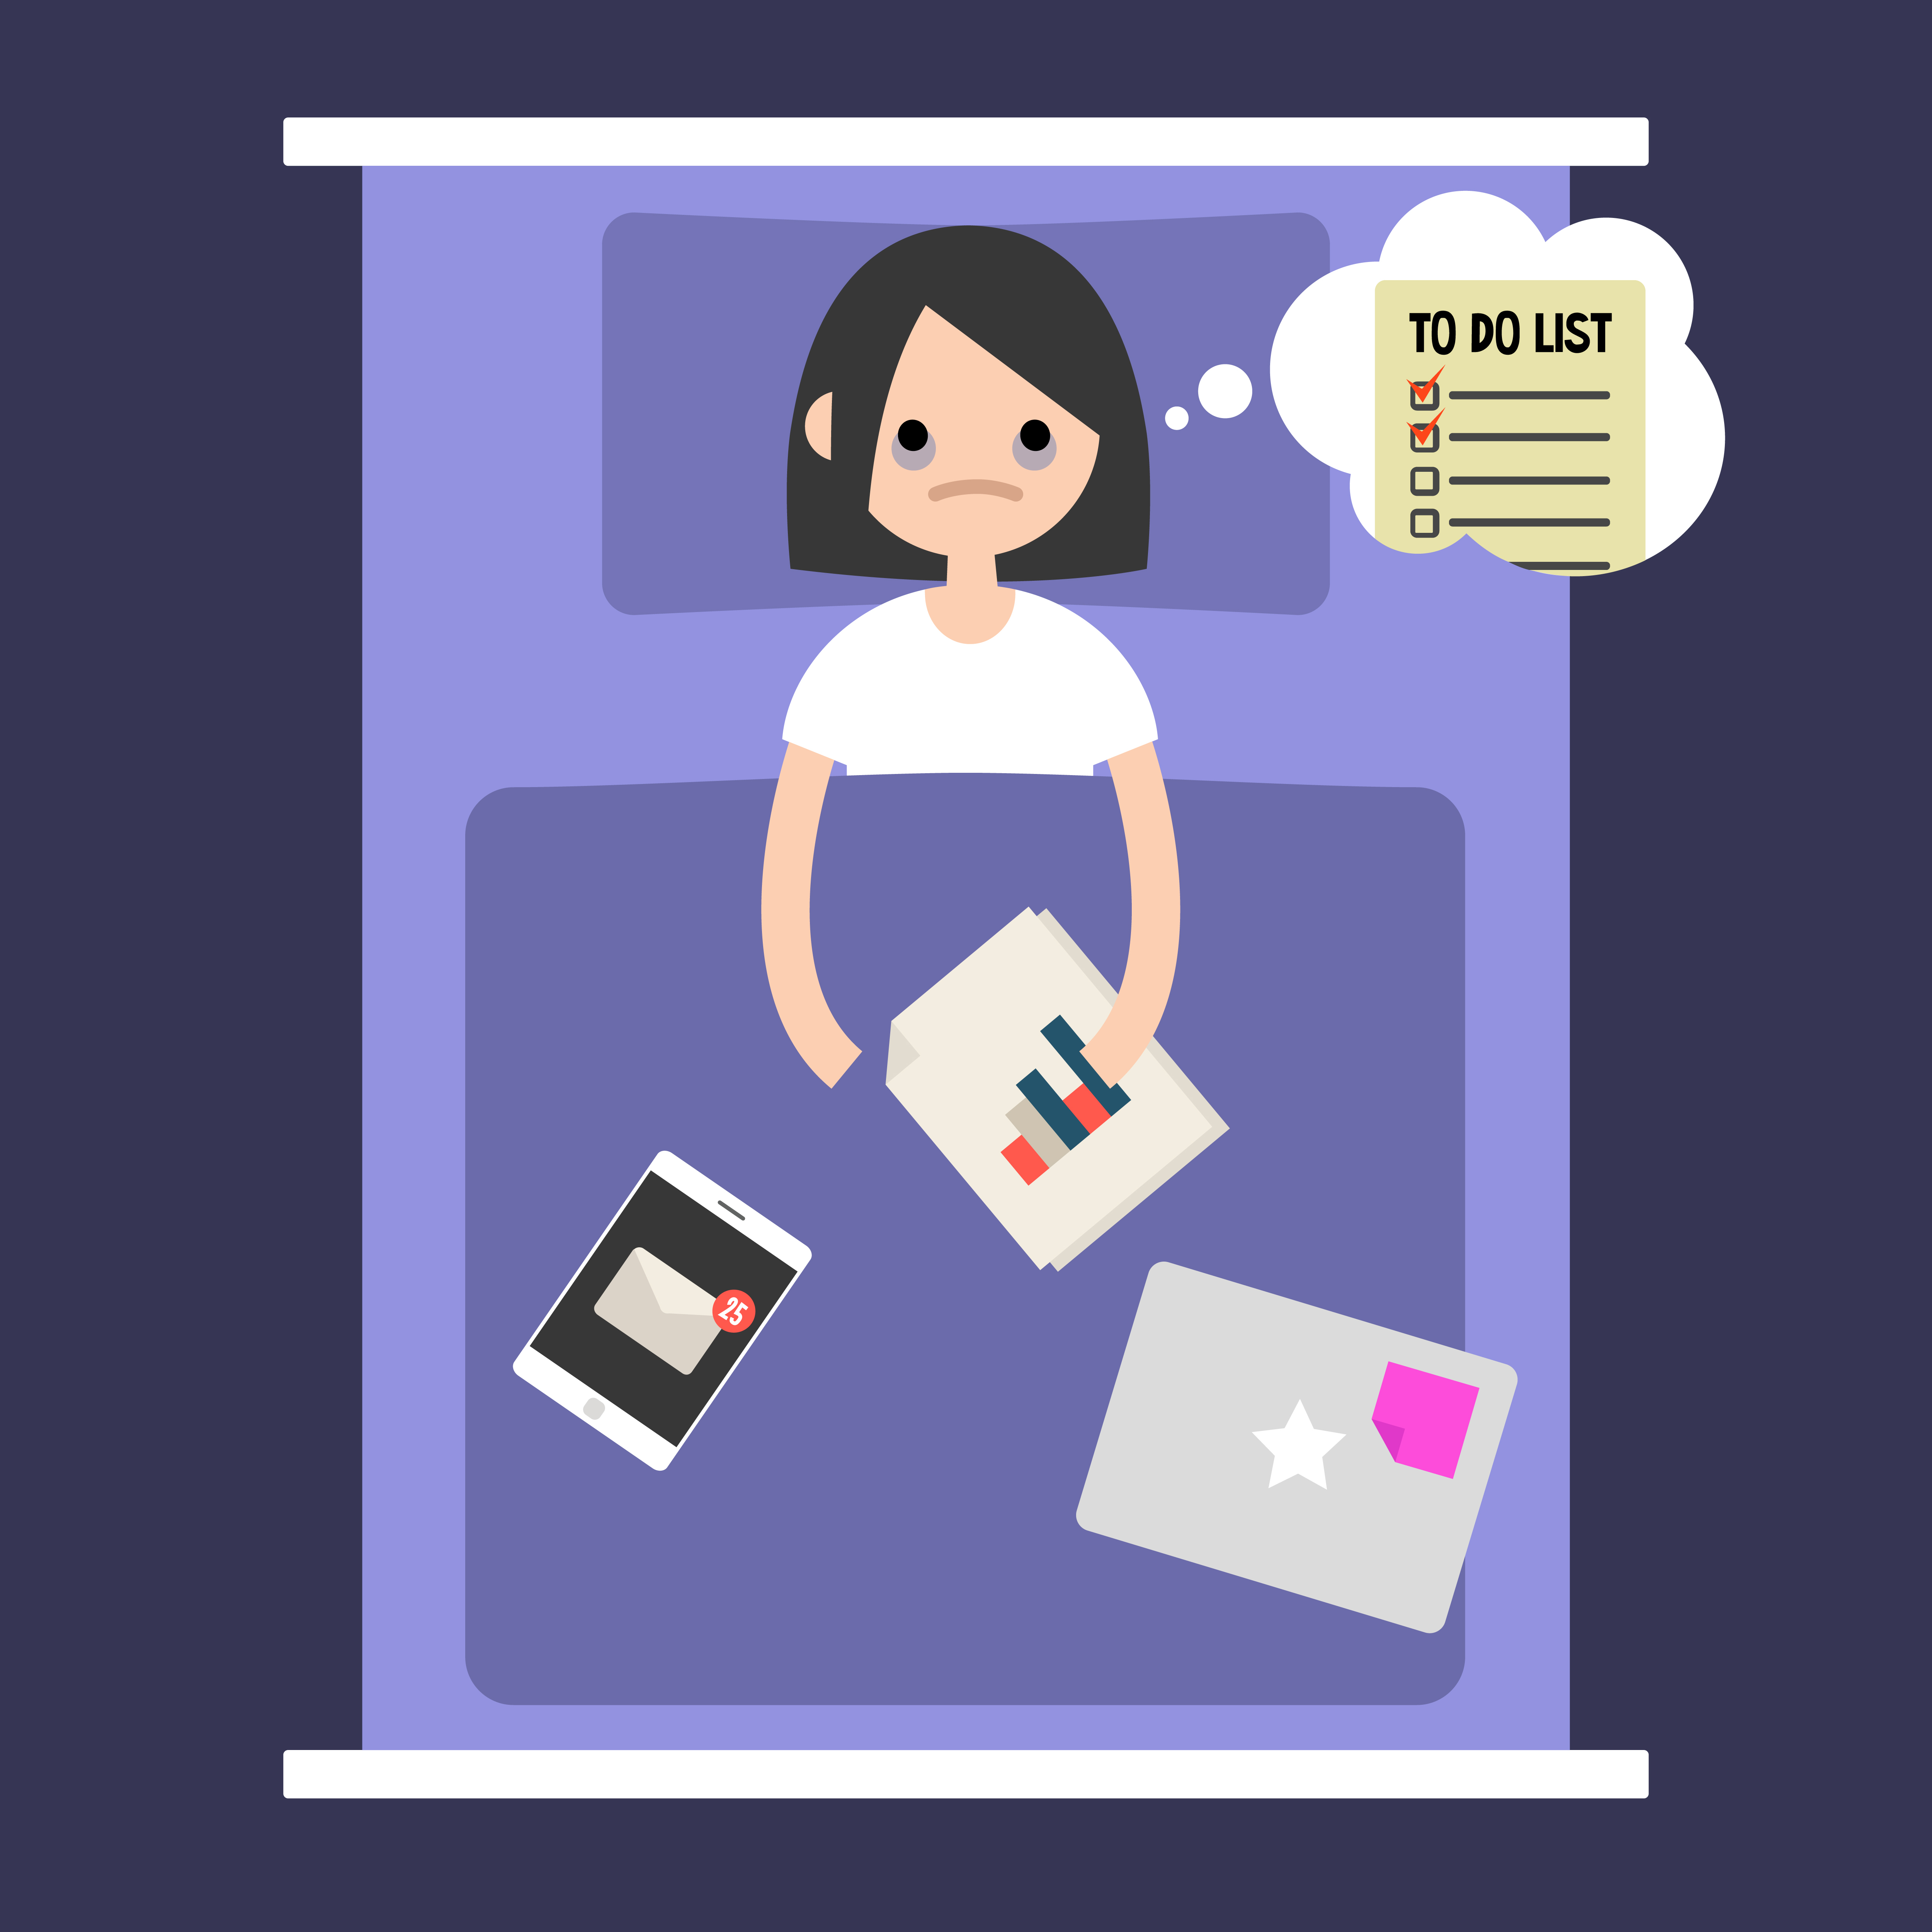

**Unit 7: Sleep and Exams: Strange Bedfellows**

Can you remember a night when you were trying and trying to get to sleep because you had a massive test in the morning? Did you notice how the more you wanted to sleep, the more sleep seemed to evade you?

You probably remember our earlier discussion about the circadian clock, which will take care of sleep for you in most circumstances. However, worrying about getting to sleep can actually freak you out enough to get in the way of the body’s own internal sleep drive which under normal circumstances allows you to fall asleep at the appropriate time.

Below are five worry busting strategies that might help ease your anxiety about sleep on the night before an exam, or at other times when you can’t stop thinking about sleep.

Worry busting strategies:

*1. Realize sleep on any one night isn’t all that important:* as long as you’re allowing body enough time to relax. You will fall asleep whenever (if ever) your sleep drive pushes you over the dreamland edge. Your body is not trying to sabotage your success. This might seem counterintuitive. You’ve learned in this program that good sleep can improve pretty much everything, so you’re probably dying to get it every night. However, you need to stay focused on the big picture. Just like one double fudge cookie milk shake will not add 50 pounds to your frame, one sleepless night will not singlehandedly cause your ruin. Sometimes you may sleep less because you are stressed. Stressing about not sleeping is bound to make things worse. As long as you sleep well on most nights you will be fine. Research has demonstrated that people with insomnia who only sleep a few hours during the night do not suffer the cognitive performance deficits suffered by people who are forcibly deprived of sleep (like night-shift workers). Your body will adapt to less sleep on a few nights.

*2. Make a list of things you have to do the next day*. This may sound unrelated, but lots of people sit up in bed thinking about the next day’s activities. They’re so worried about remembering they lose sleep…which screws up their memory. At night if you are in bed and begin to worry about remembering things you have to do the next day, draw up a quick list. Then you can drift into sleep without making a thousand mental notes that clog your brain and keep you up.

*3. Schedule a worry time:* Seem completely off the wall? Not so. If you tend to worry a lot about things that you can’t control- take control. Pick a time during the next day to think about what you have on your mind. Worrying productively may help you put things in perspective, break a problem into

manageable parts and get things done. Psychologist Marty Seligman came up with a nice way to organize productive worry time:

When faced with a difficult or distressing situation:

1. Take a mental or written inventory of the following:

a) What’s the worst possible thing that might happen to me as a result of this situation?

b) What’s the best possible outcome that could result from this situation?

c) What’s the most likely outcome of this situation?

2. Then, come up with a plan, based on the following:

a) What can I do to prevent the worst possible thing from happening? b) What can I do to increase my chances of the best possible outcome?

c) What steps can I take to improve the situation for me and others involved in the event that the most likely outcome occurs?

Organized worrying helps in lots of situations, not only with anxiety about sleep. If you are worrying about sleep you may find that after considering “the worst possible outcome” (perhaps feeling falling asleep during class), the prospect of not getting enough sleep isn’t that frightening. Lots of people fall asleep during class, and no one ever died from it. Also, you might identify some specific things you can do to help yourself unwind before bedtime so that sleep is more likely to happen, such as practicing mindfulness breathing and taking at least a few minutes after studying to unwind and enjoy the end of your day.

When it’s time for bed the next night, you will have completed your scheduled worry time and it will be more likely you can switch off your anxious thoughts and switch into sleep mode.

*4. At bedtime, try taking a mindfulness approach to worry*. Start by briefly practicing mindfulness breathing for a few minutes. Then, see if you can apply a mindfulness perspective to the experience of going to sleep. Remember that mindfulness is all about being in the moment, on purpose, in a gentle-with-self, non-judgmental way. A mindfulness perspective can be applied to almost any experience. You can practice mindfulness by allowing yourself to fully experience the moment, without any attempt to judge, problem solve, or change the situation. In short, you are in the mode of “being” rather than in the mode of “doing”. In this mode you can allow yourself to be curious rather than judgmental about thoughts, feelings, body sensations, etc. If you notice yourself worrying or thinking judgmental thoughts, simply be “curious” about these thoughts, too, and allow yourself

to let them go, bringing your attention back to the present moment. You may find that a mindfulness perspective takes the anxiety out of bedtime before big exams and at other times when you’re hoping to get a lot of sleep. And, if a mindfulness perspective with no specific focus is not working, you can return to focusing on your breathing whenever you wish.

A mindfulness perspective is the opposite of active problem solving to change things. Sometimes, the more you want to get rid of a thought, memory, worry, or emotion so you can sleep the larger it grows. Here is a simple analogous example illustrating this process:

Read the following numbers: 8, 9, 10

Now allow yourself to forget them…

Three weeks from now, if someone asked you to repeat these numbers, there is a good chance you will have successfully forgotten them. Now, what if we tell you that we’ll give you ten million dollars if you can successfully forget these numbers? If you believe us, then you will probably be less likely to “succeed” at forgetting the numbers.

The process of switching from wakefulness to sleep, like forgetting a number, is a passive process. Sometimes, the harder one tries to force sleep, the less likely the passive process will occur. The good news is that with enough time, sleep debt builds to the point that sleep takes over in spite of whatever else the mind might be doing.

*5. Learn to talk back to negative thoughts that increase worry about sleep.* Thoughts and emotions feed off each other. Anxious feelings about not being able to fall asleep feed off negative thoughts like, “I’m going fail my exam tomorrow because I can’t get enough sleep.” Learning to talk back to these thoughts can be helpful.

The best time to begin this exercise is during the day after a night when worrying about sleep seems to have made sleep more difficult. Use the worksheet below to help.

1. Write down the specific situation. For example, Jakki wrote “Laying in bed the night before my calculus final, unable to fall asleep.”

2. Record the names of the emotions that you felt. Jakki wrote “anxious, worried, and scared.”

3. Write the thoughts that ran through your mind when you felt these emotions. These can be the thoughts you actually remember, or the thoughts you have currently as you think back and reflect on the specific situation and the emotions you felt. Jill wrote the following thoughts:

“I’m going to be up all night, and I have my calculus exam tomorrow!” “I’m going to feel terrible”

and

“I’m going to fail my exam.”

4. See if you can come up with a more positive thought to replace each negative thought. Here are a few strategies that can help you.

a) Check out the evidence. What evidence is there that the negative thought is accurate? For example, Jakki might remember the fact that she’s never actually failed an exam (unless you count her cursive exam in third grade).

b) Even if the negative thought is accurate, is it really the end of the world? Jill might decide that staying up will make her irritable the next day. So she’ll avoid telling people off and maybe just avoid people in general; nothing terrible will happen.

5. Negative thoughts reinforce unpleasant emotions that can make sleep more difficult. Cognitive therapy helps people learn to talk back to negative thoughts in order to reduce unpleasant emotions. Talking back to negative thoughts is an important skill to have. Sometimes it does even help to say it out loud; wear a phone earpiece and nobody will suspect anything.

On the next two pages, you will find a cognitive therapy thought record completed with the example from Jill, followed by a blank form you can use.

|  |  |  |
| --- | --- | --- |
| Specific situation: Laying in bed the night before my calculus final, unable to fall asleep | | |
| Emotions I felt during this situation | Negative thoughts that ran through my mind | More balanced alternative thoughts |
| Anxious Worried Scared | I’m going to be up all night, and I have my calculus exam tomorrow.  I’m going to feel terrible tomorrow.  I’m going to fail my exam. | I’ve been through this before, thinking I’ll be up all night. However, I’ve always fallen asleep eventually. Chances are, I’ll fall asleep eventually tonight too.  Maybe… but so what. I’ve been through this not- sleeping-well thing before. So, I might not feel at my best tomorrow. Not a big deal. Nothing terrible has ever happened to me because I didn’t sleep much and felt less than 100%.  I’ve passed all of my  calculus exams before, even though I’ve been too  anxious to sleep well the night before most of them. |

|  |  |  |
| --- | --- | --- |
| Specific situation: | | |
| Emotions I felt during this situation | Negative thoughts that ran through my mind | More balanced alternative thoughts |
|  |  |  |

Below is a list of common negative thoughts that get in the way of sleep.

1. I won’t feel well during the day unless I get eight hours of sleep.

2. If I don’t get enough sleep tonight, I’m not going to be able to get anything done tomorrow.

3. If I don’t get enough sleep for a few days in a row, I’ll have a nervous breakdown.

4. When I have trouble getting to sleep, I should stay in bed and try harder.

5. After a poor nights sleep, it will be hard for me to focus on my academic work.

6. If I can’t get to sleep soon, I’m going to fail my test tomorrow.

7. I won’t be able to write tomorrow if I don’t get enough sleep tonight.

8. If I don’t get enough sleep, I’m going to look horrible tomorrow.

9. If I’m feeling irritable, depressed, or anxious during the day, it’s mostly because I didn’t sleep well the night before.

10. Without an adequate night’s sleep, I can hardly function the next day.

11. When I sleep poorly on one night, I know that it will disturb my sleep schedule for the whole week.

12. When I feel tired, have no energy, or just seem not to function well during the day, it is generally because I did not sleep well the night before.

13. I get overwhelmed by my thoughts at night and often feel I have no control over my racing mind.

14. Not being able to sleep well makes it hard for me to enjoy life.

15. Difficulty sleeping prevents me from doing things that are important to me.

Follow-up on the success of your sleep scheduling efforts:

1. Use your sleep log to calculate the total number of hours you have slept over the last week.

2. Divide by 7 to determine the average number of hours you sleep every night.

3. Determine the average time it takes every evening to fall asleep.

4. Determine the total average amount of time you spend in bed awake.

Here is how to make adjustments to your recommended sleep schedule, if needed:

Determine if both of the following have been true for you over the last week.

1. Are you able to fall asleep, on average, within 30 minutes at night?

2. Do you spend, on average, less than 45 minutes lying in bed awake during the night?

If you answer "yes" to both questions above, consider how refreshed you feel during the daytime. Are you tired during most daytime hours? If so, you should probably continue with your current sleep schedule. On the other- hand, if you are sleeping well during the time you schedule for sleep but remain tired during much of the day, try adding ½ hour to your sleep schedule, consistently getting up ½ hour later or going to bed ½ hour earlier, depending on your personal preference and scheduled obligations.

If you answer "no" to one or both of the questions listed above, consider making some adjustments. Are you waking up at the same time every morning? Are you avoiding alcohol late in the evening and coffee after lunchtime? If you haven’t done so already, try eliminating all caffeine after lunch time and all alcohol entirely. Be sure to avoid daytime naps longer than one hour and to avoid taking naps late in the evening. If you are already doing all of these things and are still consistently unable to fall asleep in less than 30 minutes after going to bed, or if you are spending a total of 45 minutes or more during the night lying in bed awake, consider reducing the number of hours you are scheduling for sleep by ½ hour.

However, do not restrict nighttime sleep to less than 6 hours per night. Even if you are not able to sleep for six hours in a row, allow yourself to relax in bed during six consecutive hours per night, so your body can sleep as much as it wants to during that period of time.

**Practice Suggestions:**

1. From the list of worry busting strategies above, pick the one or two that seem like the best fit for you. Practice over the next week.

2. Continue following your sleep schedule, with adjustments determined as above if needed.

3. Continue to use the 30 second sleep diary.

**Your Thirty Second Sleep Diary**

***Instructions for 30 second sleep diary:***As soon as possible after getting out of bed for the day, estimate and record the following times, so that you can estimate the total amount of time you spent in bed, the amount of time you were lying in bed awake, and the total amount of time you slept every night.

|  |  |  |  |  |  |  |  |
| --- | --- | --- | --- | --- | --- | --- | --- |
| **30 Second Sleep Diary** | Day 1 | Day 2 | Day 3 | Day 4 | Day 5 | Day 6 | Day 7 |
| 1. Time I got up for the day |  |  |  |  |  |  |  |
| 1. Time I went to bed |  |  |  |  |  |  |  |
| 1. **Total amount of time I spent in bed (a – b)** |  |  |  |  |  |  |  |
| 1. Amount of time it took me to fall asleep |  |  |  |  |  |  |  |
| 1. After initially falling asleep, amount of time I spent lying in bed awake |  |  |  |  |  |  |  |
| 1. **Total amount of time I spent in bed awake (d + e)** |  |  |  |  |  |  |  |
| **Total amount of time I spent sleeping (c – f)** |  |  |  |  |  |  |  |

**Refresh**

The science of sleep for optimal performance and well being

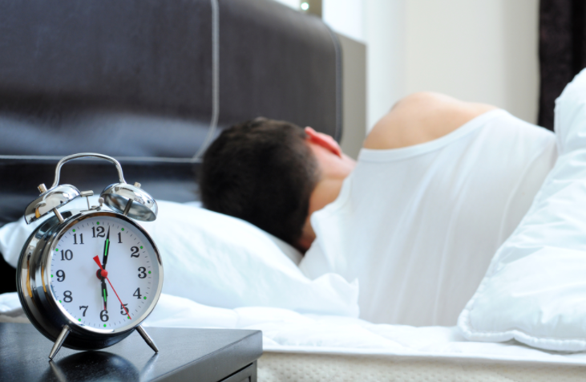

**Unit 8: Sleep Upkeep**

Follow-up on the success of your sleep scheduling efforts:

For as long as you need to, you can continue to follow the sleep scheduling program you’ve started for yourself. To continue the program, use the sleep log and review the following every week:

1. Calculate the total number of hours you have slept over the last week.

2. Divide by 7 to determine the average number of hours you sleep every night.

3. Determine the average time it takes every evening to fall asleep.

4. Determine the total average amount of time you spend in bed awake.

Here is how to make adjustments to your recommended sleep schedule, if needed:

Determine if both of the following have been true for you over the last week:

1. Are you able to fall asleep, on average, within 30 minutes at night?

2. Do you spend, on average, less than 45 minutes lying in bed awake during the night?

If you can answer yes to both of these questions and you are feeling refreshed during the daytime, you may have found a good sleep schedule for yourself. No need to change anything.

If you answer yes to both questions but note that you feel sleep deprived during the daytime, add another 15 to 30 minute increment to your sleep schedule.

If you answer no to one or both of the above questions, consider the following:

1. Has there been something new in your life causing you to worry? Or has something really good and exciting happened? If so, the best strategy is probably not to worry. Keep doing what you’re doing and your sleep will catch up with you in time.

2. Have you added too much time to your sleep schedule? If you were sleeping through the night more consistently when you were scheduling a shorter block of time for sleep, consider reducing your scheduled sleep time by 15 to 30 minutes.

3. Review the healthy sleep habits below. Have you adopted all of them?

Now, let’s review some of the other things you’ve been learning over the last several weeks:

What parts of the Refresh program did you most useful?

Have your sleep habits changed over the period of time you’ve been using this program? Consider each of the following 10 healthy sleep habits. Compared to your sleep habits prior to using the Refresh program, do you do these things more frequently, equally frequently, or less frequently?

Compared to my sleep habits before I started using the Refresh program, I now (check one response for each item):

1. Go to bed at the same time every evening (within one hour), weekdays and weekends.

More frequently Equally frequently

Less frequently

2. Get up every morning at the same time (within one hour), weekdays and weekends.

More frequently Equally frequently

Less frequently

3. Obtain morning exposure to sunlight within one hour of waking up.

More frequently Equally frequently

Less frequently

4. Avoid late afternoon or evening naps.

More frequently Equally frequently

Less frequently

5. Restrict early afternoon naps to less than one hour.

More frequently Equally frequently

Less frequently

6. Practice mindfulness meditation or a relaxation technique daily.

More frequently Equally frequently

Less frequently

7. Eliminate caffeine intake or reduce it during the 6 hours preceding bedtime.

More frequently Equally frequently

Less frequently

8. Eliminate or reduce alcohol consumption prior to bedtime.

More frequently Equally frequently

Less frequently

9. Allow 60 to 90 minutes before bedtime to “unwind” by engaging in relaxing activities (i.e. no intense physical exercise or difficult homework assignment).

More frequently Equally frequently

Less frequently

10. Talk back to negative thoughts that might prevent you from sleeping.

More frequently Equally frequently

Less frequently

What have been the benefits of the new habits you’ve adopted as you’ve completed this program?

One month from now (or as often as you wish), review and add to this list of benefits you’ve realized and review the list of 10 healthy sleep habits. Keep all the materials from this program in a file where you can review them as needed. Good job so far, and best of luck with your efforts to maintain your new healthy sleep habits.